CST2355 – Database Systems

Winter 2023

Created by: Sarfraz Khan

The below document demonstrates how to create a new user, scott in this case and create oracle’s sample tables i.e. dept, emp, etc. In case you want to create a user with your name, just replace ‘SCOTT’ with your preferred username.
1. Login as SYS and check the existing users in oracle database:
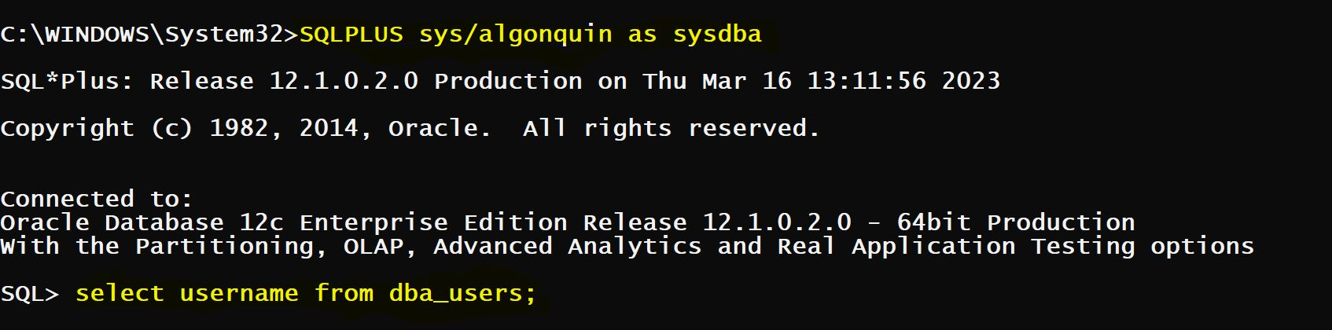

2.Login as SYS, If not already logged in and check the existing users in oracle database:
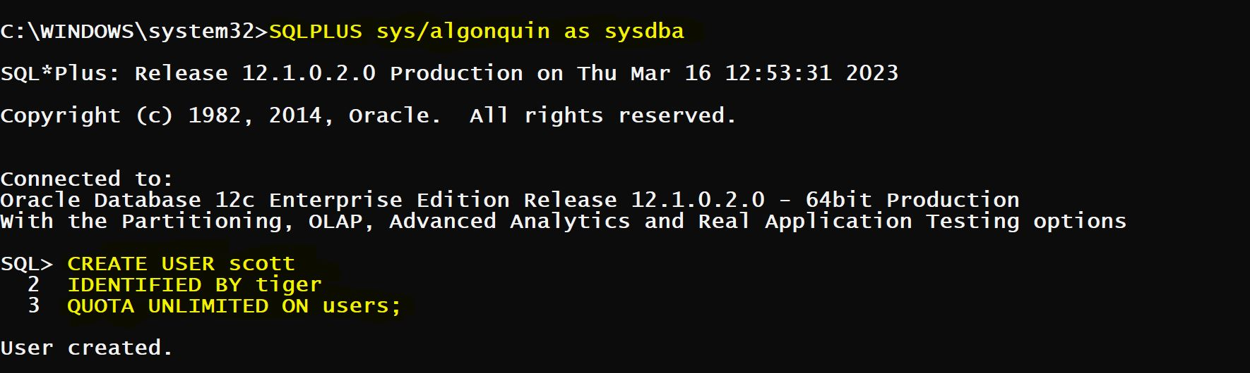
3.Now, grant user scott CONNECT and RESOURCE roles.
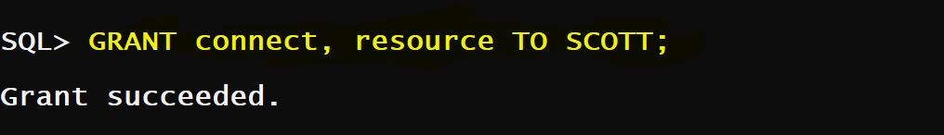

4.Login as SCOTT and check the privileges SCOTT has received through the CONNECT and RESOURCE roles:
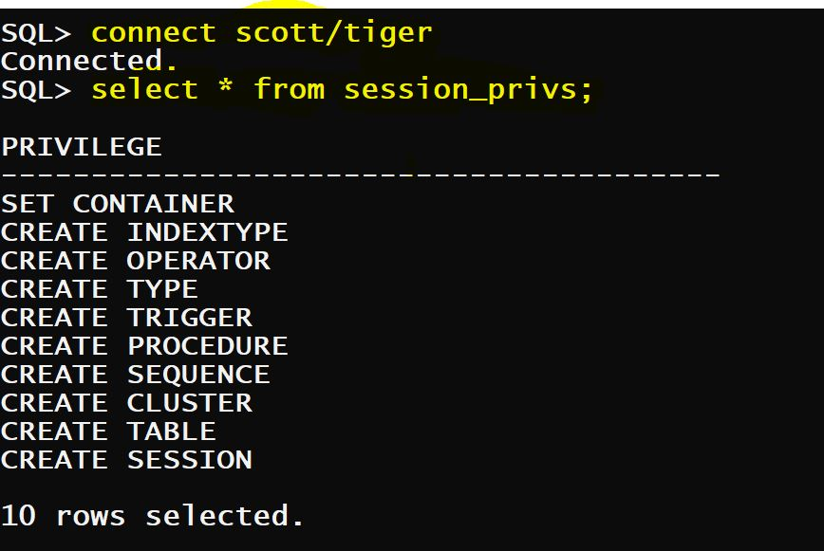

5. Now, we need to create the sample tables under SCOTT user. Copy paste & execute the below script as SCOTT user to have all these tables created and populated with sample data.
/* The Below Script will create EMP, DEPT, BONUS, SALGRADE & DUMMY Tables. Run this script under SCOTT user or any other user account to create and populate these tables */

DROP TABLE EMP;
DROP TABLE DEPT;
DROP TABLE BONUS;
DROP TABLE SALGRADE;
DROP TABLE DUMMY;

CREATE TABLE DEPT
(DEPTNO NUMBER(2) CONSTRAINT pk_deptno PRIMARY KEY,
DNAME VARCHAR2(14),
LOC VARCHAR2(13) );

INSERT INTO DEPT VALUES (10, 'ACCOUNTING', 'NEW YORK');
INSERT INTO DEPT VALUES (20, 'RESEARCH', 'DALLAS');
INSERT INTO DEPT VALUES (30, 'SALES', 'CHICAGO');
INSERT INTO DEPT VALUES (40, 'OPERATIONS', 'BOSTON');

CREATE TABLE EMP
(EMPNO NUMBER(4) CONSTRAINT pk_empno PRIMARY KEY,
ENAME VARCHAR2(10),
JOB VARCHAR2(9),
MGR NUMBER(4),
HIREDATE DATE,
SAL NUMBER(7, 2),
COMM NUMBER(7, 2),
DEPTNO NUMBER(2) CONSTRAINT fk_deptno REFERENCES dept(deptno));

INSERT INTO EMP VALUES
(7369, 'SMITH', 'CLERK', 7902,
TO_DATE('17-DEC-1980', 'DD-MON-YYYY'), 800, NULL, 20);
INSERT INTO EMP VALUES
(7499, 'ALLEN', 'SALESMAN', 7698,
TO_DATE('20-FEB-1981', 'DD-MON-YYYY'), 1600, 300, 30);
INSERT INTO EMP VALUES
(7521, 'WARD', 'SALESMAN', 7698,
TO_DATE('22-FEB-1981', 'DD-MON-YYYY'), 1250, 500, 30);
INSERT INTO EMP VALUES
(7566, 'JONES', 'MANAGER', 7839,
TO_DATE('2-APR-1981', 'DD-MON-YYYY'), 2975, NULL, 20);
INSERT INTO EMP VALUES
(7654, 'MARTIN', 'SALESMAN', 7698,
TO_DATE('28-SEP-1981', 'DD-MON-YYYY'), 1250, 1400, 30);
INSERT INTO EMP VALUES
(7698, 'BLAKE', 'MANAGER', 7839,
TO_DATE('1-MAY-1981', 'DD-MON-YYYY'), 2850, NULL, 30);
INSERT INTO EMP VALUES
(7782, 'CLARK', 'MANAGER', 7839,
TO_DATE('9-JUN-1981', 'DD-MON-YYYY'), 2450, NULL, 10);
INSERT INTO EMP VALUES
(7788, 'SCOTT', 'ANALYST', 7566,
TO_DATE('09-DEC-1982', 'DD-MON-YYYY'), 3000, NULL, 20);
INSERT INTO EMP VALUES
(7839, 'KING', 'PRESIDENT', NULL,
TO_DATE('17-NOV-1981', 'DD-MON-YYYY'), 5000, NULL, 10);
INSERT INTO EMP VALUES
(7844, 'TURNER', 'SALESMAN', 7698,
TO_DATE('8-SEP-1981', 'DD-MON-YYYY'), 1500, 0, 30);
INSERT INTO EMP VALUES
(7876, 'ADAMS', 'CLERK', 7788,
TO_DATE('12-JAN-1983', 'DD-MON-YYYY'), 1100, NULL, 20);
INSERT INTO EMP VALUES
(7900, 'JAMES', 'CLERK', 7698,
TO_DATE('3-DEC-1981', 'DD-MON-YYYY'), 950, NULL, 30);
INSERT INTO EMP VALUES
(7902, 'FORD', 'ANALYST', 7566,
TO_DATE('3-DEC-1981', 'DD-MON-YYYY'), 3000, NULL, 20);
INSERT INTO EMP VALUES
(7934, 'MILLER', 'CLERK', 7782,
TO_DATE('23-JAN-1982', 'DD-MON-YYYY'), 1300, NULL, 10);

CREATE TABLE BONUS
(ENAME VARCHAR2(10),
JOB VARCHAR2(9),
SAL NUMBER,
COMM NUMBER);

CREATE TABLE SALGRADE
(GRADE NUMBER,
LOSAL NUMBER,
HISAL NUMBER);

INSERT INTO SALGRADE VALUES (1, 700, 1200);
INSERT INTO SALGRADE VALUES (2, 1201, 1400);
INSERT INTO SALGRADE VALUES (3, 1401, 2000);
INSERT INTO SALGRADE VALUES (4, 2001, 3000);
INSERT INTO SALGRADE VALUES (5, 3001, 9999);

COMMIT;

/* Now, lets us check all the tables are created */
SELECT * FROM tab;
SELECT * FROM dept;
SELECT * FROM emp;
/

